Eliminating Ableism in Education.
Name
Institutional Affiliation
Course
Instructor
Date

Eliminating Ableism in Education.
Thomas Hehir describes and explains ableism as the devaluation of disability. He says this causes a negative societal attitude which shows that it is better to do things the way one person does as compared to others. For example, it’s better to read than to use braille or better to speak than sign. Hehir gives six proposals to help in addressing ableism in Education.

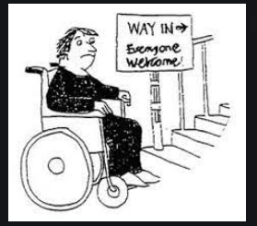

Fighting discrimination would help end ableism as this would help every individual to learn that human beings are equal no matter the challenges (Camminga, 2020). Fighting the negative cultural values in our societies may also play a major role in eliminating ableism. With this, children with disabilities should be educated and should receive equivalent rights from the rest.

References
Camminga, B. (2020). Disregard and danger: Chimamanda Ngozi Adichie and the voices of trans (and cis) African feminists. The Sociological Review, 68(4), 817-833.

